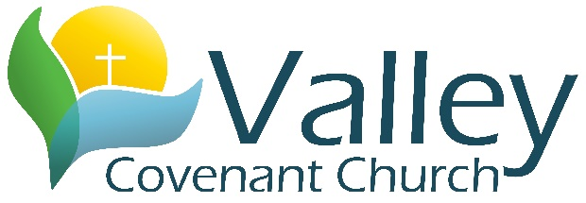

103 S. Maple St., Stillman Valley, IL 61084 - 815-645-8872

Parental/Legal Guardian Consent and Medical Authorization for 2023/24
Name of Student: _____________________________________________________________________________
Grade: _____________ Birthday: ______________ Student Phone: _________________________
Address: ____________________________________________________________________________________
Parent Name: ______________________________________ Parent Phone: ___________________________
Parent Name: ______________________________________ Parent Phone: ___________________________
As the parent (or legal guardian) of the above mentioned student:
I understand that my child will be participating in a number of activities for the calendar school year [2023-24], which carry with them a certain degree of risk. Some of the activities may include youth group trips, retreats, sports, games, and other activities that may include swimming or other physical activity. I consent for my child to participate in these activities.
I also confirm that my child is physically/mentally fit and has the necessary skills to safely participate in these activities. I confirm that if my child is not physically/mentally fit to participate, I will need to communicate this to the church, in order to provide a safe environment for my child to participate. (NOTE: All students are welcome regardless of physical/mental ability, as we will accommodate as necessary.)
I also understand and give consent for my child to travel to and from special events when necessary in transportation provided by volunteer drivers appointed by Valley Evangelical Covenant Church. I also understand that I will be asked for permission again for my student to participate in special trips and give permission to allow this form for medical authorization
Medical Treatment Authorization
It is my understanding that the church will attempt to notify me as soon as appropriate in the case of a medical emergency involving my child. If the church cannot reach me, then I authorize the church to take the necessary steps, including but not limited to the use of emergency medical, professional care from a doctor or other health-care professional. I give my permission to the doctor or other health-care professional to provide the medical services he or she may deem necessary for life-saving or the well-being of my child. I will pay for any medical expenses so incurred.
I will notify the church if I feel there are any health considerations that would prevent my child’s participation.
I also give my permission for the church’s children’s and/or youth leaders to restrict my child from participation in any activity for the sake of their health or safety.
Allergies and Other Health Considerations: ______________________________________________
____________________________________________________________________________________
Parent/Guardian Signature: ________________________________________ Date: _______________________

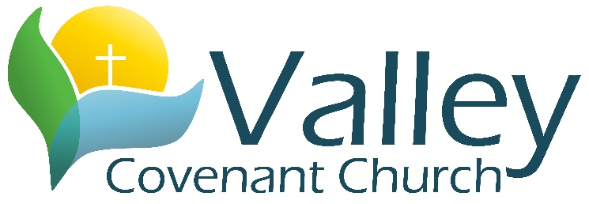

103 S. Maple St., Stillman Valley, IL 61084 - 815-645-8872

Fusion Student Ministries Expectations Agreement Form for 2023/24
The following policies and expectations will be met by all youth attending activities sponsored by VECC:
- I will abstain from the use of alcohol, tobacco or drugs of any kind.
- I will respect and adhere to ALL of Valley Covenant Church’s health and safety measures that are put in place, so that I may help keep our gathered times as safe as possible.
- I will not use foul or offensive language
- I will not engage in any action or participate in any gossip that could be considered bullying or belittling of anyone while at youth group activities, whether student or leader, present or outside of the group.
- I will wear clothing appropriate for the activities of the youth group.
- I will refrain from excessive public displays of affection.
- I will respect all others property and the property of Valley Covenant Church.
- I will respect others political, religious, or lifestyle beliefs, even if they differ from my own. This includes respecting the Christian beliefs and practices of Valley Covenant Church.
- I will help make the youth group a safe environment by honoring others stories and refraining from speaking to anyone outside of the group about anything that may be shared.
- I will respect the authority of the persons in charge of any given activity.
- I will remember that I am a representative of Valley Covenant Church and our Fusion youth group community.
In the event that I do not meet these expectations, my parent or guardian may be contacted and I may be asked to leave the activity. If this situation occurs, my parent/guardian will be responsible for providing transportation home – wherever I may be.
For parents: I give my student permission to participate in the Fusion youth activities with Valley Covenant Church and understand the expectations placed on my student, as well as, all other students attending. I also commit to help honor these expectations by partnering with leaders at Valley Covenant to make it a safe place for all.

Student Name (Print): ___________________________ Signature: ______________________________

Parent/Guardian Signature: ________________________________________ Date: _______________

